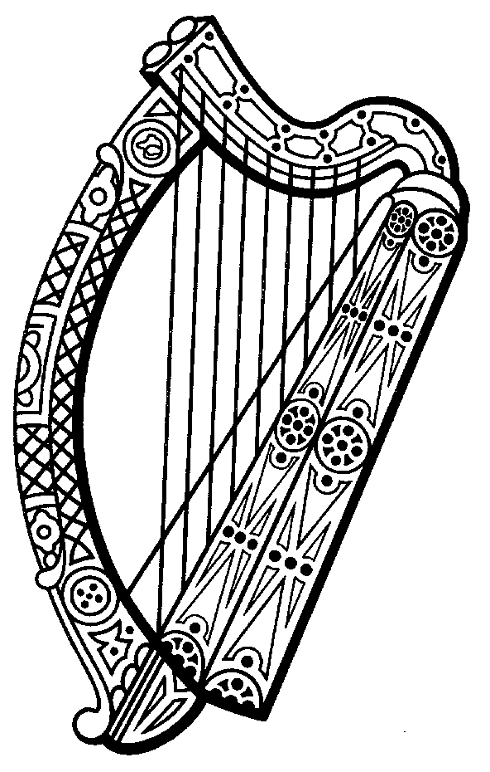

CORONERS ACTS 1962-2020

Notice of Inquest

Coroner’s District: Kildare

Place of Inquest: Athy Courthouse, County Kildare

Date of Inquest: Wednesday, 31st January 2024.

Sitting Commencing at 10.00 am
Hearings

WITHOUT JURY
10.00am

22.458 B Gary Adams 12/07/2022 Kildare

10.45 am

22.011 B Mark Hensey 04/01/2023 Leixlip

WITH JURY

11.30 am

21.525 B Billy Mooney 28/07/2021 Naas

12.30 pm

22.251 B Michael Hartigan 28/03/2022 Naas
1.30 pm

22.336 B Anna Ciwinska 11/02/2022 Naas

